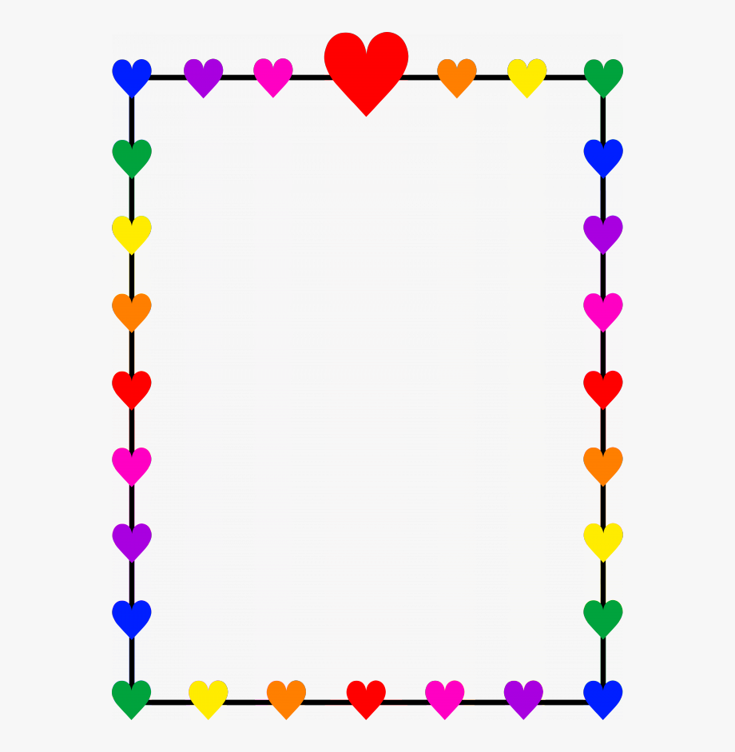
Dear Boys and Girls,
I hope you are having a great summer spending time outside in the sunshine riding bikes, swimming, playing with friends, and having picnics!
I am going to be your teacher this year in Kindergarten! I am very excited for the school year to begin. Even though this year will look and be a little different, it won’t stop us from having fun! From projects to lessons; we will sing, dance, explore and create. You will learn all about adding and subtracting numbers and you will also learn how to read and write stories!
I hope you will be able to join us for the “Welcome Back Walk Through” on August 24, 2020! Kindergarten will be from 4:00 – 4:40. Last names beginning with A-M will have from 4:00 – 4:20. Last names beginning with N-Z will have from 4:20 – 4:40. You can come to our classroom (room 218), I will show you our room, your seating area, where your cubbie is and you can put away your school supplies if you have them with you. Please make sure you write down any questions you might have and have them ready! I will try to answer to the best of my ability. If we run out of time you can always call or email me at any time.
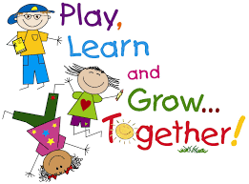
Enjoy the rest of the summer! I am anxious to see you and get started with our kindergarten year together. I will see you soon.
Sincerely,
Mrs. Davis

8:00 -8:20 Arrival | *Masks should be worn into the building and until students are at their seats and not close to anyone
8:00 – 8:40 Breakfast | Breakfast this year will be delivered to the classroom. Once students arrive they will complete a daily checklist to unpack and get ready for the day. After they are able to go right to their seats and start breakfast. During this time students may talk with their friends while social distancing.
8:45-9:00 Morning Meeting | Start the day with calendar and number corner
9:00 -10:02 Math/ Special (Tues) | Math (M/W/TH/F) *Masks will be worn for stations  Special: PE - T
10:06-10:54 Special/ Math | Specials: PE -M/W/F  Music-TH  Math: T *Masks will be worn for stations
11:00-11:40 Recess/Lunch | Recess will be outside unless raining or below 0 degrees  Lunch – Nomnomz while social distancing -*Masks will be worn until students are at their assigned seats
11:45-12:00 Quiet Time | Yoga, Story Time, Relaxation!
12:00 -1:00 LA | Language Arts/Daily 4 Stations *Masks will be worn for stations
1:00-1:30 Writing
1:30-1:45 Recess | Recess will be outside unless raining or below 0 degrees
1:45-2:00 Snack | Please note: All snacks should be INDIVIDUALY prepackaged!
2:00- 2:30 Science / S.S | Mrs. Skogman- Science T/TH  Mrs. Davis – Social Studies M/W
2:30-2:50 Centers | *Masks will be worn for centers if unable to social distance
2:50-3:10 Pack Up | Complete daily checklist for dismissal
3:10 Dismissal | *Masks will be worn on the bus or until students are picked up by parents

***Masks will be worn anytime we are unable to social distance in the classroom or around the school. This will be during station time, in the hallways, at recess, etc. ***

